catalogue
Chapter1 Product Introduction 4
1.1 Factory default 4
1.2 Get device information 4
Chapter 2 Wireless settings 5
2.1 Pairing setup code 5
2.2 BLE BLUETOOTH MODE 5
2.3 Mode Selection 5
2.4 Set the upload data speed delay 6
2.5 Check software version 6
2.6 Set sleep time 6
2.7 USB KBW 7
2.8 USB COM 7
2.9 Output format 7
2.10 Output forced letter case conversion 9
Chapter 3 Input/Output Settings 10
Introduction 10
Startup Beeper 10
Trigger Click Beeper 10
Good Read and Error Read Indicators 11
Manual mode 12
Induction mode 13
Continuous mode 14
Chapter 4 Data Editing 18
Introduction 18
Add Preﬁx or Suﬃx 19
Example 20
Keyboard Operation 22
Clear Preﬁxes or Suﬃxes 23
Preﬁx Selections 23
Suﬃx Selections 24
Function Code Transmit 25
Chapter 5 Symbologies 26
Introduction 26
All Symbologies 27
1D Barcode 28
2D Barcode 28
Codabar 29
Code 39 33
Code 32 Pharmaceutical (PARAF) 36
Interleaved 2 of 5 38
NEC 2 of 5 41
Code 93 44
Straight 2 of 5 Industrial (three-bar start/stop) 45
Code 11 49
Code 128 51
ISBT 128 Concatenation 51
GS1-128 53
UPC-A 55
UPC-E0 58
UPC-E1 62
ISBN Translate 64
EAN/JAN-8 65
MSI 68
Check Characte 69
GS1 DataBar Omnidirectional 70
GS1 DataBar Limited 70
Korea Post 77
Check Digit 78
Han Xin Code 78
Maxi code 80
Micropdf 81
Composites 81
Codablock A 83
Scan the barcode to disable GS1 Data Matrix 85
Show Software Revision 86
2D Symbologies 91
ASCII Conversion Chart 93
Programming Charts 100

1、Product Introduction

Factory default
- End：Enter(\r)。


Factory default

Get device information
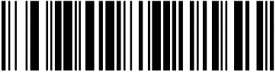
Obtain the version number

2 Wireless settings

2.1 Pairing setup code
①Pair the receiver: Scan the following two barcodes in sequence.And connect the receiver to computer；
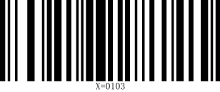
2.4G MODE Connecting devices

②Pair Bluetooth devices in HID mode: Scan the following two barcodes in sequence, turn on the Bluetooth device to search for RB_Scanner_HID connection.

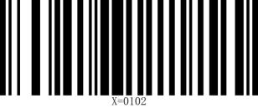
HID MODE Connect

2.2 BLE BLUETOOTH MODE
Pairing Bluetooth devices: Scan the following two barcodes in sequence, and perform Bluetooth search RB_Scanner_BLE on the software that supports BLE
Connect.Note: BLE mode needs to be output on specific software (Bluetooth serial port) 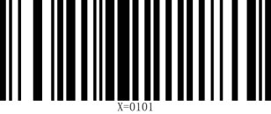
BLE MODE Connect

2.3 Mode Selection
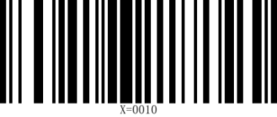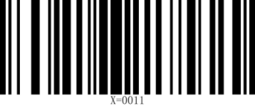
Instant upload mode Inventory Mode

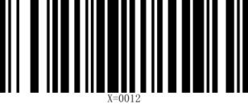
Over-the-distance storage mode

①Operations in Inventory Mode

Upload all data Upload new data (that is, data that has not been uploaded before)
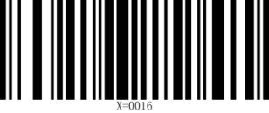
Display saved data Showing unuploaded data
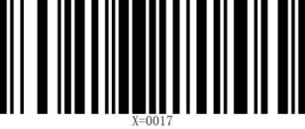
Clear all data

2.4 Set the upload data speed delay
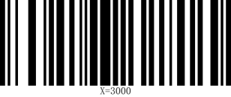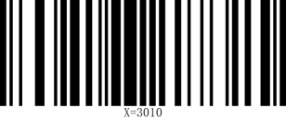
No delay Delay 10ms
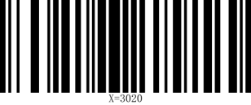

Delay 20ms

2.5 Check software version
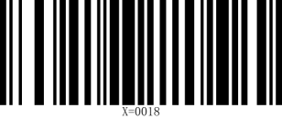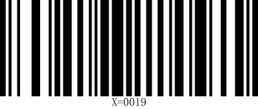
Check the scanner software version Check the receiving end version number

2.6 Set sleep time
X=1yyy(x=1000 means no sleep, sleep time calculation formula: yyy*10=z seconds)
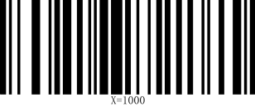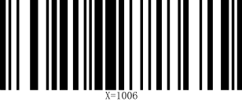
No sleep 60 seconds

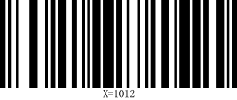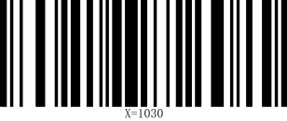
120 seconds 5 minutes

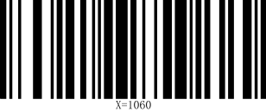
10 minutes

2.7 USB KBW
When the scanner is connected to the host using a USB receiver, the scanner can be configured as a standard keyboard input by scanning the USB KBW setup code.
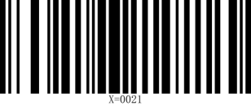
USB KBW keyboard

2.8 USB COM
When the scanner is connected to the host using a USB receiver, the receiver virtual serial port output mode can be changed by scanning the USB COM setup code.
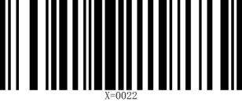
USB COM

2.9 Output format
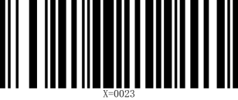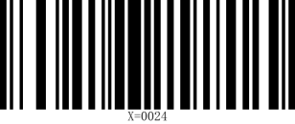
UTF-8 GBK

When the scanner recognizes it as a keyboard input device, different countries have different input characters, so you need to set different national languages. The keyboard defaults to the US language.
2.10 multi-language keyboards
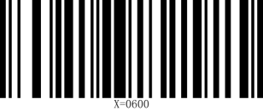U.S. (default) 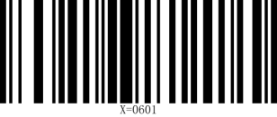Belgium (French)

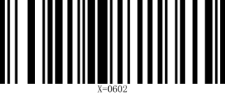Brazil (Portuguese) 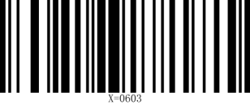 Canada

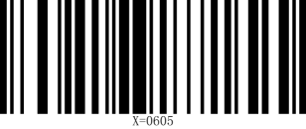Czech Republic 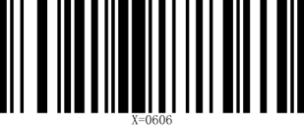 Denmark

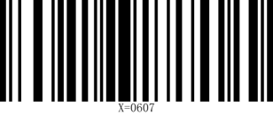Finland 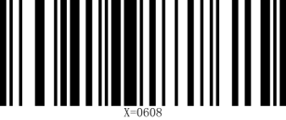France

Germany 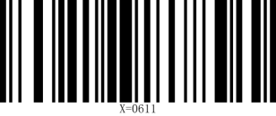Italy

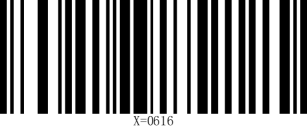Portugal 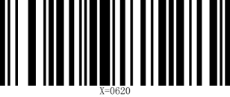Spain

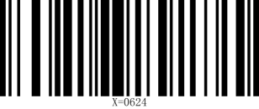Türkiye-F 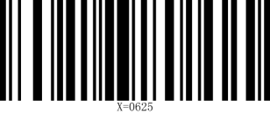Türkiye-Q

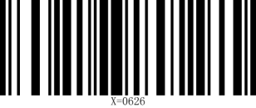U.K. 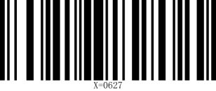 Japan

Russia 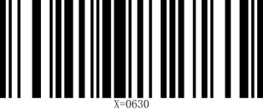Vietnamese

2.11 Output forced letter case conversion
Letter conversion, when outputting barcodes with letter content, you can configure the output result to be all uppercase or all lowercase. For example, if the barcode content is: ab123dE, if you scan the "Convert to uppercase" barcode, the output result is: AB123DE; if you scan the "Convert to lowercase" barcode, the output result is: abc123de; the default case is not converted.
Case conversion
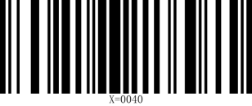
Do not convert Uppercase

Lowercase Case conversion

Chapter 3 Input/Output Settings

Introduction
This chapter mainly introduces the conﬁguration of the beep and LED of the barcode scanner when it is powered on, decoded, and triggered by the button.

Startup Beeper
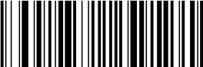
The scanner can be programmed to beep when it’s started up. Default = Startup Beeper On.

(8410130.)
Startup Beeper Off
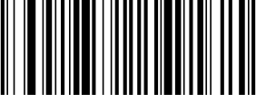

（8410131.)
* Startup Beeper On

Trigger Click Beeper
To hear an audible click every time the scanner button is pressed, scan the Trigger Click Beeper On barcode below. Default = Trigger Click Beeper Off.
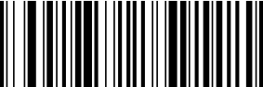

(8410140.)
*Trigger Click Beeper Off
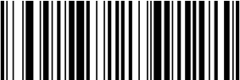

(8410141.)
Trigger Click Beeper On

Good Read and Error Read Indicators

Good Read Beeper
The beeper may be programmed On or Off in response to a good read. Default = Good Read Beeper On.

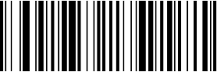
(8410010.)
Good Read Beeper Off

Good Read Beeper Volume

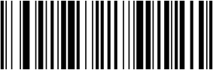

(8410011.)
* Good Read Beeper On

The beeper volume codes modify the volume of the beep the scanner emits on a good read. Default = High.
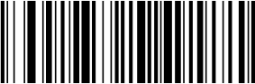

(8410091.)
Low
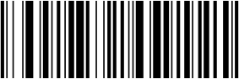

(8410092.)
Medium
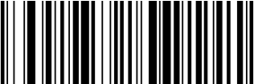

(8410093.)
* High
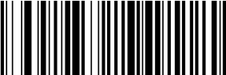

(8410090.)
Off

Good Read Beeper Frequency
The beeper frequency codes modify the frequency of the beep the scanner emits on a good read. Default = Medium.
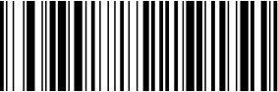

(8410061600.)
Low (1600 Hz)


(8410062400.)
* Medium (2400 Hz)
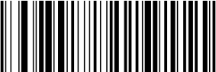

(8410064200.)
High (4200 Hz)

Good Read Beeper Duration
The beeper duration codes modify the length of the beep the scanner emits on a good read. Default = Normal .


(8410020.)
* Normal

Error Read Beeper Frequency
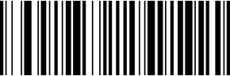

(8410021.)
Short

The beeper frequency codes modify the frequency of the sound the scan- ner emits when there is a bad read or error. Default = Razz.
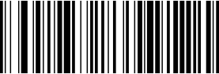

(841007250.)
* Razz (250 Hz)

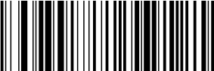(8410073250.
Medium (3250 Hz)
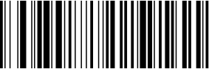

(8410074200.)
High (4200 Hz)

Good Read LED
The LED indicator can be programmed On or Off in response to a good read. Default = On.
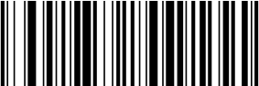

(8410081.)
* Good Read LED On
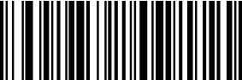

(8410080.)
Good Read LED Off

Manual mode
The manual reading mode is the default reading mode. In this mode, the recognition engine starts reading the code after the user presses the trigger key, and stops reading the code after successfully outputting information or the user releases the trigger key.

(8610020.)

Induction mode
After setting up, there is no need to trigger, and the recognition engine immediately starts monitoring the brightness of the surrounding environment. When the scene changes, the recognition engine waits for the set stabilization time to end before starting to read the code. If the following situation does not occur, the reading engine will cycle in the above way: if the barcode is not scanned within a single reading time, the reading engine will automatically pause reading and enter the monitoring state. In the induction reading mode, the reading engine can also start reading the code after the user presses the trigger button. When the code reading is successful and outputs information or the user releases the trigger button, it will switch to induction mode for 5 seconds and continue to monitor the brightness of the surrounding environment.

(8610023.)
sensitivity
Self sensing sensitivity, the higher the sensitivity, the easier it is to wake up, but it is easy to accidentally wake up the device to decoding mode, default to high.


High(8610054.)*


Mid(8610055.)


Low(8610056.)
Continuous mode
After setting up, there is no need to trigger. The reading engine immediately starts reading the code. During the reading process, the user can also manually pause the reading by clicking the trigger button. When the reading is successful and outputs information or the user releases the trigger button, it will switch to continuous mode for 5 seconds 
(8610028.)
Same barcode reading delay
Sensing mode and continuous mode scanning can be used to set the time interval between barcode scanning equipment reading the next barcode after reading one barcode.。
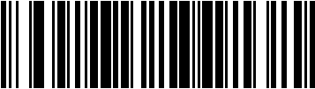
(8510060.)
No time interval

(851006500.)
(500ms)

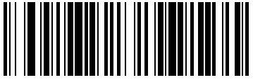

(851006750.)

(750 ms)


(8510061000.)

(1,000 ms)
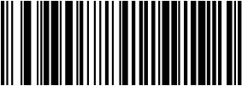
(8510061500.)

(1,500 ms

Chapter 4 Data Editing

Introduction
This chapter describes how to add preﬁxes and suﬃxes.

- Default preﬁx = None. Default suﬃx = None.
- A preﬁx or suﬃx may be added or cleared from one symbology or all symbologies.
- You can add any preﬁx or suﬃx from the ASCII Conversion Chart deplus Code I.D. and AIM I.D.
- Enter preﬁxes and suﬃxes in the order in which you want them to appear on the output.
- When setting up for speciﬁc symbologies (as opposed to all symbologies), the speciﬁc symbology ID value counts as an added preﬁx or suﬃx character.
- The maximum size of a preﬁx or suﬃx conﬁguration is 200 characters, which includes header information.

Add Preﬁx or Suﬃx
Step 1. Scan the Add Preﬁx or Add Suﬃx symbol
Step 2. Determine the 2 digit Hex value from the Symbology Chart for the symbology to which you want to apply the preﬁx or suﬃx. For example, for Code 11, Code ID is “h” and Hex ID is “68”.
Step 3. Scan the 2 hex digits from the Programming Chart inside the back cover of this manual or scan 9, 9 for all symbologies.
Step 4. Determine the hex value from the ASCII Conversion Chart , for the preﬁx or suﬃx you wish to enter.
Step 5. Scan the 2 digit hex value from the Programming Chart inside the back cover of this manual.
Step 6. Repeat Steps 4 and 5 for every preﬁx or suﬃx character.
Step 7. To add the Code I.D., scan 5, C, 8, 0.
To add AIM I.D., scan 5, C, 8, 1.
To add a backslash (\), scan 5, C, 5, C.
Step 8. Scan Save to exit and save, or scan Discard to exit without saving.
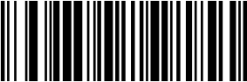

(889002.)
Add Preﬁx
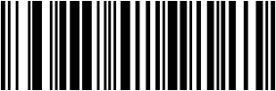

(888002.)
Add Suﬃx
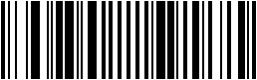

(800002.)

Save

(800000.)
Disgard

Example

Add a Suﬃx to a speciﬁc symbology
To send a CR (carriage return)Suﬃx for code 128. only:
Step 1. Scan Add Suﬃx.
Step 2. Determine the 2 digit hex value from the Symbology Charts for code 128.
Step 3. Scan 6, 3 from the Programming Chart inside the back cover of this manual.
Step 4. Determine the hex value from the ASCII Conversion Chart , for the CR (carriage return).
Step 5. Scan 0, D from the Programming Chart inside the back cover of this manual.
Step 6. Scan Save, or scan Discard to exit without saving.

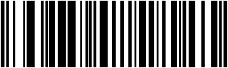
(888002.)
Add Suﬃx

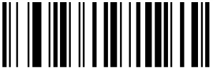
(KAK.)
A

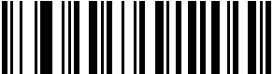
(SDS.)

D

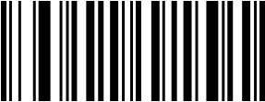
(K6K.)

6


(K0K.)

0

(800002.)
Save

To Add a Carriage Return Suﬃx to All Symbologies
Scan the following barcode if you wish to add a carriage return suﬃx to all symbologies at once. This action ﬁrst clears all current suﬃxes, then programs a carriage return suﬃx for all symbologies.


(890000.)
Add CR Suﬃx All Symbologies

To Add a Line Break Suﬃx to All Symbologies
Scan the following barcode if you wish to add a line break suﬃx to all symbologies at once. This action ﬁrst clears all current suﬃxes, then programs a line break suﬃx for all symbologies.
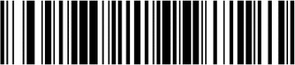

(888002990A.)
Add LF Suﬃx All Symbologies

To Add a Carriage Return &a Line Break Suﬃx to All Symbologies
Scan the following barcode if you wish to add a carriage return suﬃx and a line break suﬃx to all symbologies at once. This action ﬁrst clears all current suﬃxes, then programs a carriage return suﬃx and a line break suﬃx for all symbologies.
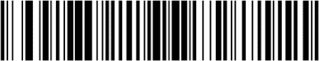

(888002990D0A.)
Add CR and LF Suﬃx All Symbologies

Keyboard Operation
Different operations can be performed on the keyboard through conﬁguration during decoding output, such as automatic saving after decoding output.
Step 1: determine the hexadecimal value corresponding to the keyboard operation to be performed from the ASCII conversion of keyboard operation, and Determine the 2-digit hexadecimal value of the barcode to be set
Step 2. scan the barcode of "add keyboard operation".
Step 3. Determine the sequence of keyboard operation and barcode output. If keyboard operation is in front, scan "add preﬁx" barcode, and then scan "add suﬃx" barcode.
Step 4. Scan the corresponding 4-digit hexadecimal values in the Programming Charts of this manual according to the corresponding hexadecimal values (including barcode type and corresponding keyboard operation)
Step 5. Scan "save" barcode.
Step 6, scan "end adding keyboard operation"
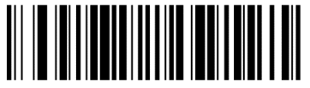
（8210042）
Add keyboard operation
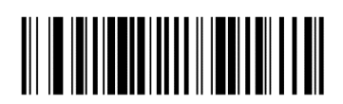
（8210040）
End adding keyboard operation
Example: add operation that automatic preservation after decoding output for all kinds of barcodes
First, conﬁrm the operation to be performed: save after barcode output, so suﬃx should be added after output barcode. Then determine the corresponding hexadecimal value according to the table in the appendix,all kinds of barcodes correspond to “9”“9”，The save operation corresponds to “1”“3”。
After conﬁrmation, scan "add keyboard operation" barcode, add suﬃx barcode, 9, 9, 1, 3, and then scan "save" barcode and “end adding keyboard operation” barcode
(Here "9" and "9" correspond to all coding systems, and "1" and "3" correspond to decoding output and saving)

Clear Preﬁxes or Suﬃxes
You can clear a single preﬁx or suﬃx, or clear all preﬁxes/suﬃxes for a symbology. If you have been entering preﬁxes and suﬃxes for single sym- bologies, you can use Clear One Preﬁx (Suﬃx) to delete a speciﬁc char- acter from a symbology. When you Clear All Preﬁxes (Suﬃxes), all the preﬁxes or suﬃxes for a symbology are deleted.
Step 1. Scan the Clear One Preﬁx or Clear One Suﬃx symbol.
Step 2. Determine the 2 digit Hex value from the Symbology Charts for the symbology from which you want to clear the preﬁx or suﬃx.
Step 3. Scan the 2 digit hex value from the Programming Chart inside the
back cover of this manual or scan 9, 9 for all symbologies.
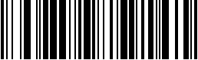
Step 4. Scan the Save symbol.

(889004.)

Clear One Preﬁx
(888004.)

Clear One Suﬃx

(800002.)
Save


Preﬁx Selections

(889002.)
Add Preﬁx

(889004.)
Clear One Preﬁx

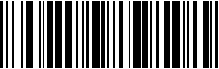
(889003.)
Clear All Preﬁxes

Suﬃx Selections



(888002.)
Add Suﬃx

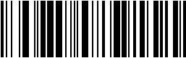

(888003.)
Clear All Suﬃxes



(888004.)
Clear One Suﬃx

Function Code Transmit
When this selection is enabled and function codes are contained within the scanned data, the scanner transmits the function code to the terminal. Default = Disable.
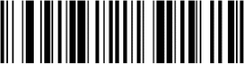

(8080071.)
*Enable

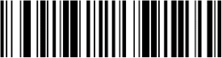

(8080070.)
*Disable

Chapter 5 Symbologies

Introduction
Each type of barcode has its own unique properties. The barcode scanner can be adjusted to accommodate these property changes through the conﬁguration code in this chapter. The fewer the barcode types, the faster the barcode scanner can read. You can disable the barcode scanner to read the barcode types that will not be used to improve the performance of the barcode scanner.

All Symbologies
If you want to decode all the symbologies allowable for your scanner, scan the All Symbologies On barcode. If on the other hand, you want to decode only a particular symbology, scan All Symbologies Off followed by the On barcode for that particular symbology.

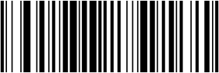

(9990011.)
All Symbologies On

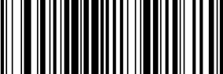

(9990010.)
All Symbologies Off

Note: When All Symbologies On is scanned, 2D Postal Codes are not enabled.
2D Postal Codes must be enabled separately.

Message Length Description
You are able to set the valid reading length of some of the barcode symbolo- gies. If the data length of the scanned barcode doesn’t match the valid read- ing length, the scanner will issue an error tone. You may wish to set the same value for minimum and maximum length to force the scanner to read ﬁxed length barcode data. This helps reduce the chances of a misread.
EXAMPLE: Decode only those barcodes with a count of 6-10 characters.
Min. length = 06 Max. length = 10
Step 1. Select the barcode symbology to set the maximum reading length or the minimum reading length, scan the Minimum Message Length barcode in its catalog, and scan the number “6” and “Save” barcodes from the Programming Chart .
Step 2. Scan the Maxmum Message Length barcode and scan the numbers
1, 0 barcode and Save barcode from the Programming Chart . The above process sets the selected barcode symbology small reading length to 6 and the maximum reading length to 10

EXAMPLE: Decode only those barcodes with a count of 13 characters.
Min. length = 13 Max. length = 13

1D Barcode
If the bar code scanning device needs to decode all the one-dimensional code systems, please scan the bar code of “All 1D Barcode on”. Only solve speciﬁc code system, please scan " All 1D Barcode off" .
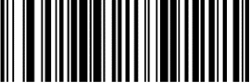

(9950040.)
All 1D Barcode on

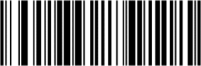

2D Barcode

(9950041.)
All 1D Barcode off

If the bar code scanning device needs to decode all the two-dimensional code systems, please scan the bar code of “All 2D Barcode on”. Only solve speciﬁc code system, please scan " All 2D Barcode off"

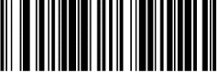

(9950070.)
All 2D Barcode on

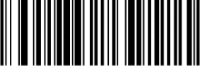

(9950071.)
All 2D Barcode on

Codabar

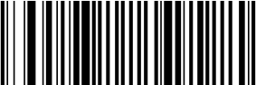
On/Off

(9000031.)
* On

Start/Stop Characters

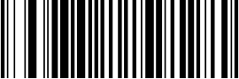

(900000.)
Default All Codabar Settings

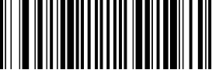
(9000030.)
Off

Start/Stop characters identify the leading and trailing ends of the barcode. You may either transmit, or not transmit Start/Stop characters.Default = Don’t Transmit.
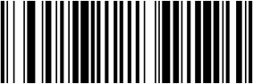

(9000061.)
Transmit
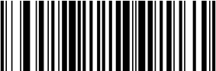

Check Character

(9000060.)
* Don’t Transmit

No Check Character indicates that the scanner reads and transmits barcode data with or without a check character.
When Check Character is set to Validate and Transmit, the scanner will only read Codabar barcodes printed with a check character, and will transmit this character at the end of the scanned data.
When Check Character is set to Validate, but Don’t Transmit, the unit will only read Codabar barcodes printed with a check character, but will not transmit the check character with the scanned data. Default = No Check Character.

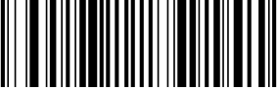
(9000010.)
* No Check Character

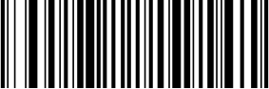

(9000012.)
Validate and Transmit

(9000011.)
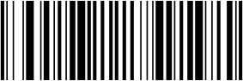
Validate but Don’t Transmit

Concatenation
Codabar supports symbol concatenation. When you enable concatena- tion, the scanner looks for a Codabar symbol having a “D” start character, adjacent to a symbol having a “D” stop character. In this case the two mes- sages are concatenated into one with the “D” characters omitted.
A 1 2 3 4 D D 5 6 7 8A
Select Require to prevent the scanner from decoding a single “D” Codabar symbol without its companion. This selection has no effect on Codabar symbols without Stop/Start D characters.
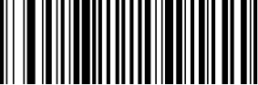

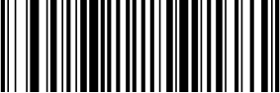
(9000021.)
On

(9000020.)
* Off

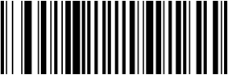
(9000022.)
Require

Message Length
Scan the barcodes below to change the message length. Refer to Message Length Description for additional information. Minimum and Maximum lengths = 2-60. Minimum Default = 4, Maximum Default = 60.


(900005.)
Minimum Message Length


(900004.)
Maximum Message Length

Code 39

< Default All Code 39 Settings >


(901000.)
Default All Code 39 Settings

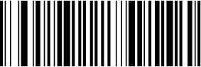
Code 39 On/Off

(9010011.)
* On

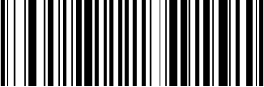

(9010010.)
Off

Start/ Stop Characters
Start/Stop characters identify the leading and trailing ends of the barcode. You may either transmit, or not transmit Start/Stop characters. Default = Don’t Transmit.
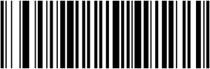

(9010091.)
Transmit
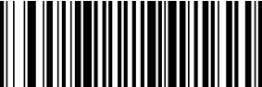

(9010090.)
* Don’t Transmit

Check Character
No Check Character indicates that the scanner reads and transmits bar- code data with or without a check character.
When Check Character is set to Validate, but Don’t Transmit, the unit only reads Code 39 barcodes printed with a check character, but will not transmit the check character with the scanned data.
When Check Character is set to Validate and Transmit, the scanner only reads Code 39 barcodes printed with a check character, and will transmit this character at the end of the scanned data. Default = No Check Character.
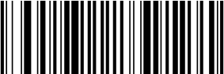

(9010040.)
* No Check Character


(9010041.)
Validate, but Don’t Transmit
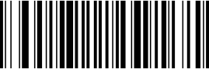

(9010042.)
Validate and Transmit

Message Length
Scan the barcodes below to change the message length. Refer to Message Length Description for additional information. Minimum and Maximum lengths
= 0-48. Minimum Default = 0, Maximum Default = 48.


(901008.)
Minimum Message Length


(901007.)
Maximum Message Length

Code 39 Append
This function allows the scanner to append the data from several Code 39 barcodes together before transmitting them to the host computer. When the scanner encounters a Code 39 barcode with the append trigger char- acter(s), it buffers Code 39 barcodes until it reads a Code 39 barcode that does not have the append trigger. The data is then transmitted in the order in which the barcodes were read (FIFO). Default = Off.
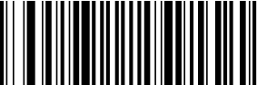

(9010021.)
On

Example

(9010020.)
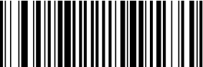
* Off

After sanning on barcode, scan the three bar codes below in order. The barcode scanner does not output any data until the last bar code is scanned. After scanning the ESS barcode, the SUCCESS word is output correctly.

SU
CC
ESS

Code 32 Pharmaceutical (PARAF)
Code 32 Pharmaceutical is a form of the Code 39 symbology used by Ital- ian pharmacies. This symbology is also known as PARAF.
When you conﬁgure code32, you need to turn on code39 before you conﬁgure it.
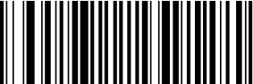

(9010051.)
On
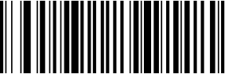

(9010050.)
* Off

FULL ASCII
If Full ASCII Code 39 decoding is enabled, certain character pairs within the bar- code symbol will be interpreted as a single character. For example:$V will be decoded as the ASCII character SYN, and /C will be decoded as the ASCII character #. Default = Off.

NUL%U | DLE $P | SP SPACE | 0 | 0 | @%V | P | P | ‘ %W | p +P
SOH$A | DC1 $Q | ! /A | 1 | 1 | A A | Q | Q | a +A | q +Q
STX $B | DC2 $R | “ /B | 2 | 2 | B B | R | R | b +B | r +R
ETX $C | DC3 $S | # /C | 3 | 3 | C C | S | S | c +C | s +S
EOT $D | DC4 $T | $ /D | 4 | 4 | D D | T | T | d +D | t +T
ENQ $E | NAK $U | % /E | 5 | 5 | E E | U | U | e +E | u +U
ACK $F | SYN $V | & /F | 6 | 6 | F F | V | V | f +F | v +V
BEL $G | ETB $W | ‘ /G | 7 | 7 | G G | W | W | g +G | w +W
BS $H | CAN $X | ( /H | 8 | 8 | H H | X | X | h +H | x +X
HT $I | EM $Y | ) /I | 9 | 9 | I I | Y | Y | i +I | y +Y
LF $J | SUB $Z | * /J | : | /Z | J J | Z | Z | j +J | z +Z
VT $K | ESC %A | + /K | ; | %F | K K | [ | %K | k +K | { %P
FF $L | FS %B | , /L | < | %G | L L | \ | %L | l +L | | %Q
CR $M | GS %C | - /M | = | %H | M M | ] | %M | m +M | } %R
SO $N | RS %D | . /N | > | %I | N N | ^ | %N | n +N | ~ %S
SI$O | US %E | / /O | ? | %J | O O | _ | %O | o +O | DEL %T

Character pairs /M and /N decode as a minus sign and period respectively. Character pairs /P through /Y decode as 0 through 9.
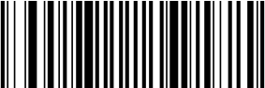

(9010031.)
FULL ASCII On


(9010030.)
* FULL ASCII Off

Interleaved 2 of 5
< Default All Interleaved 2 of 5 Settings >

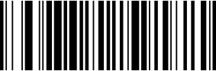

On/Off

(902000.)
Default All Interleaved 2 of 5 Settings

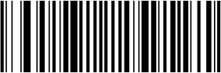

(9020021.)
* On



Check Digit

(9020020.)
Off

No Check Digit indicates that the scanner reads and transmits barcode data with or without a check digit.
When Check Digit is set to Validate, but Don’t Transmit, the unit only reads Interleaved 2 of 5 barcodes printed with a check digit, but will not transmit the check digit with the scanned data.
When Check Digit is set to Validate and Transmit, the scanner only reads Interleaved 2 of 5 barcodes printed with a check digit, and will transmit this digit at the end of the scanned data. Default = No Check Digit.
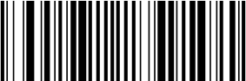

(9020010.)
* No Check Digit
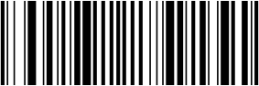

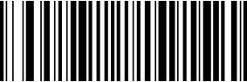

(9020012.)
Validate and Transmit

(9020011.)
Validate, but Don’t Transmit

Message Length
Scan the barcodes below to change the message length. Refer to Message Length Description for additional information. Minimum and Maximum lengths
= 2-80. Minimum Default = 4, Maximum Default = 80.
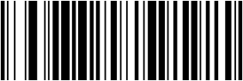

(902004.)
Minimum Message Length
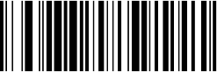

(902003.)
Maximum Message Length

NEC 2 of 5


On/Off

< Default All NEC 2 of 5 Settings >

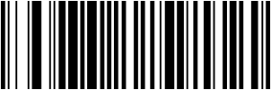

(903000.)
Default All NEC 2 of 5 Settings

(9030011.)
* On

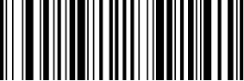

(9030010.)
Off

Check Digit
No Check Digit indicates that the scanner reads and transmits barcode data with or without a check digit.
When Check Digit is set to Validate, but Don’t Transmit, the unit only reads NEC 2 of 5 barcodes printed with a check digit, but will not transmit the check digit with the scanned data.
When Check Digit is set to Validate and Transmit, the scanner only reads NEC 2 of 5 barcodes printed with a check digit, and will transmit this digit at the end of the scanned data. Default = No Check Digit
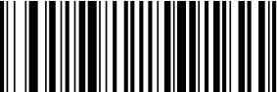

(9030020.)
* No Check Digit

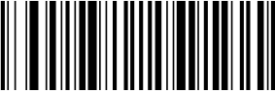

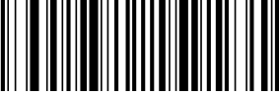

(9030022.)
Validate and Transmit

(9030021.)
Validate, but Don’t Transmit

Message Length
Scan the barcodes below to change the message length. Refer to Message Length Description for additional information. Minimum and Maximum lengths
= 2-80. Minimum Default = 4, Maximum Default = 80.
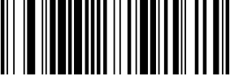

(903004.)
Minimum Message Length
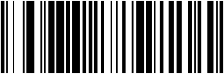

(903003.)
Maximum Message Length

Code 93

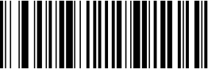
On/Off

< Default All Code 93 Settings >


(904000.)
Default All Code 93 Settings

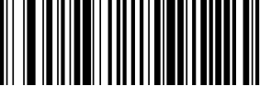
(9040021.)
* On

(9040020.)
Off

Message Length
Scan the barcodes below to change the message length. Refer to Message Length Description for additional information. Minimum and Maximum lengths = 0-80. Minimum Default = 0, Maximum Default = 80.
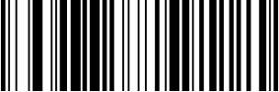

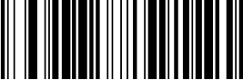
(904004.)
Minimum Message Length

(904003.)
Maximum Message Length

Straight 2 of 5 Industrial (three-bar start/stop)

<Default All Straight 2 of 5 Industrial Settings>


(905000.)
Default All Straight 2 of 5 Industrial (three-bar start/stop)Settings

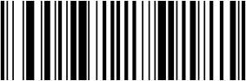
On/Off

(9050011.)
On


(9050010.)
* Off

Message Length
Scan the barcodes below to change the message length. Refer to Message Length Description for additional information. Minimum and Maximum lengths = 1-48. Minimum Default = 4, Maximum Default = 48.


(905003.)
Minimum Message Length



(905002.)
Maximum Message Length

(906000.)
Default All Straight 2 of 5 IATA (two-bar start/stop)Settings

On/Off


(9060011.)
On



Message Length

（9060010.）
Off

Scan the barcodes below to change the message length. Refer to Message Length Description for additional information. Minimum and Maximum lengths = 1-48. Minimum Default = 4, Maximum Default = 48.


(906003.)
Minimum Message Length
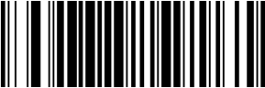

(906002.)
Maximum Message Length

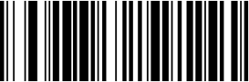

On/Off

(907000.)
Default All Matrix 2 of 5 Settings



(9070011.)
On

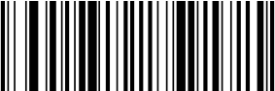

Message Length

(9070010.)
* Off

Scan the barcodes below to change the message length. Refer to Message Length Description for additional information. Minimum and Maximum lengths = 1-80. Minimum Default = 4, Maximum Default = 80.


(907003.)
Minimum Message Length
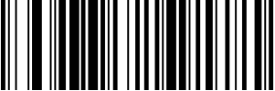

(907002.)
Maximum Message Length

Check

Scan the barcode below to enable or disable the check function of matrix25.
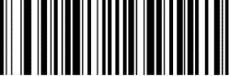

(9070051.)
Enable Check Function
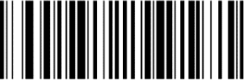

(9070050.)
Disable Check Function

Code 11

On/Off

<Default All Settings>


(908000.)
Default All Code 11 Settings

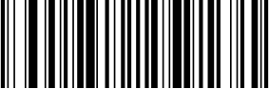

(9080021.)
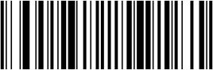
On

(9080020.)
* Off

Check Digits Required
This option sets whether 1 or 2 check digits are required with Code 11 barcodes. Default = Two Check Digits.
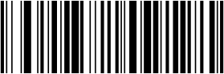

(3110280.)
One Check Digit
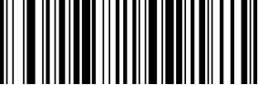

(3110281.)
* Two Check Digits

Message Length
Scan the barcodes below to change the message length. Refer to Message Length Description for additional information. Minimum and Maximum lengths = 1-80. Minimum Default = 4, Maximum Default = 80.
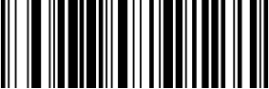

(908004.)
Minimum Message Length
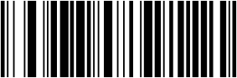

(908003.)
Maximum Message Length

Code 128

<Default All Code 128 Settings>
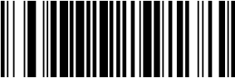

(909000.)
Default All Code 128 Settings

On/Off
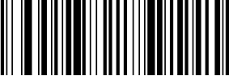

(9090011.)
* On

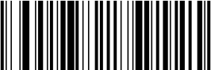

(9090010.)
Off

ISBT 128 Concatenation

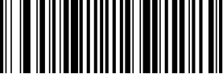

(9020051.)
ISBT 128 On

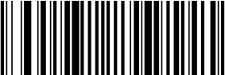

(9020050.)
*ISBT 128 Off

Message Length
Scan the barcodes below to change the message length. Refer to Message Length Description for additional information. Minimum and Maximum lengths = 0-80. Minimum Default = 0, Maximum Default = 80.


(909003.)
Minimum Message Length


(909002.)
Maximum Message Length

GS1-128

<Default All GS1-128 Settings>
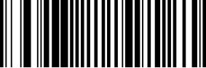

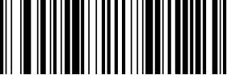
On/Off

(9100011.)
* On

Message Length

(910000.)
Default All GS1-128 Settings


(9100010.)
Off

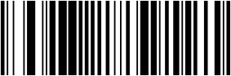
Scan the barcodes below to change the message length. Refer to Message Length Description for additional information. Minimum and Maximum lengths = 1-80. Minimum Default = 1, Maximum Default = 80.

(910003.)
Minimum Message Length
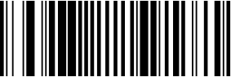

(910002.)
Maximum Message Length

Telepen

<Default All Telepen Settings>
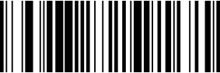

On/Off

(911000.)
Default All Telepen Settings


(9110011.)
On

Message Length

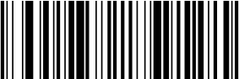

(9110010.)
* Off

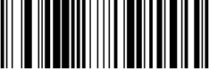
Scan the barcodes below to change the message length. Refer to Message Length Description for additional information. Minimum and Maximum lengths = 1-60. Minimum Default = 1, Maximum Default = 60.

(911003.)
Minimum Message Length

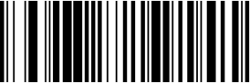

(911002.)
Maximum Message Length

UPC-A

<Default All UPC-A Settings>
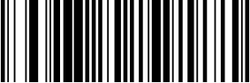

(912000.)
Default All UPC-A Settings

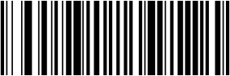
(9120031.)
* On

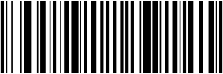

(9120030.)
Off

Check Digit
This selection allows you to specify whether the check digit should be transmitted at the end of the scanned data or not. Default = On.
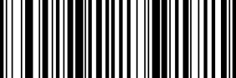

(9120041.)
* On
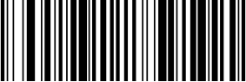

(9120040.)
Off

Number System
The numeric system digit of a U.P.C. symbol is normally transmitted at the beginning of the scanned data, but the unit can be programmed so it will not transmit it. Default = On.
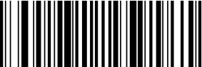

(9120051.)
* On

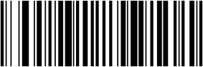

Addenda

(9120050.)
Off

This selection adds 2 or 5 digits to the end of all scanned UPC-A data. Default = Off for both 2 Digit and 5 Digit Addenda.
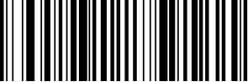

(9120011.)
2 Digit Addenda On
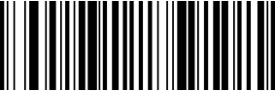

(9120010.)
* 2 Digit Addenda Off
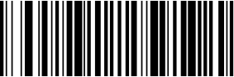

(9120021.)
5 Digit Addenda On
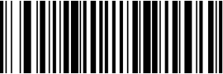

(9120020.)
* 5 Digit Addenda Off

Addenda Required
When Required is scanned, the scanner will only read UPC-A barcodes that have addenda. You must then turn on a 2 or 5 digit addenda. Default = Not Required.
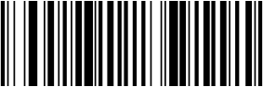

(9120061.)
Required



Addenda Separator

(9120060.)
* Not Required

When this feature is on, there is a space between the data from the barcode and the data from the addenda. When turned off, there is no space. Default
= On.
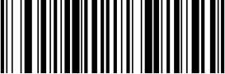

(9120071.)
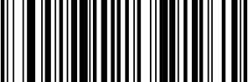
* On

Note

(9120070.)
Off

Scan the barcode below to convert UPC-A to EAN_13 or not.
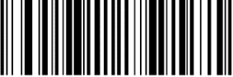

(9120111.)
Convert

(9120110.)
Not convert

UPC-E0

On/Off

<Default All UPC-E Settings>


(914000.)
Default All UPC-E0 Settings

Most U.P.C. barcodes lead with the 0 number system. To read these codes, use the *UPC-E0 On selection. If you need to read codes that lead with the 1 number system, use UPC-E1. Default = On.
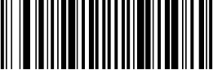

(9140101.)
* UPC-E0 On
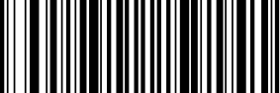

(9140100.)
UPC-E0 Off

Expand
UPC-E Expand expands the UPC-E code to the 12 digit, UPC-A format. Default = Off.


(9140021.)
On
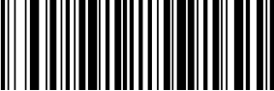

(9140020.)
* Off

Addenda Required
When Required is scanned, the scanner will only read UPC-E barcodes that have addenda. Default = Not Required.
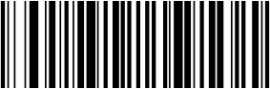

(9140031.)
Required

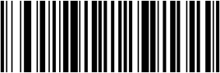

Addenda Separator

(9140030.)
* Not Required

When this feature is On, there is a space between the data from the barcode and the data from the addenda. When turned Off, there is no space. Default = On
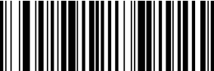

(9140041.)
* On

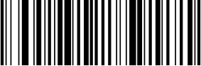

Check Digit

(9140040.)
Off

Check Digit speciﬁes whether the check digit should be transmitted at the end of the scanned data or not. Default = On.
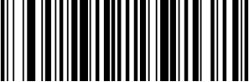

(9140051.)
*On
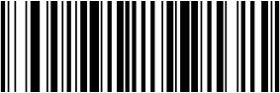

(9140050.)
Off

Number System
The numeric system digit of a U.P.C. symbol is normally transmitted at the beginning of the scanned data, but the unit can be programmed so it will not transmit it. To prevent transmission, scan Off. Default = On.
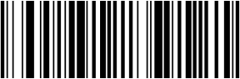

(9140061.)
* On

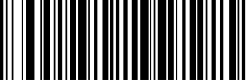

Addenda

(9140060.)
Off

This selection adds 2 or 5 digits to the end of all scanned UPC-E data.Default = Off for both 2 Digit and 5 Digit Addenda.
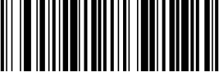

(9140071.)
2 Digit Addenda On
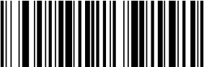

(9140070.)
* 2 Digit Addenda Off
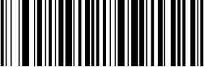

(9140081.)
5 Digit Addenda On
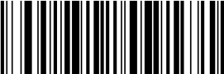

(9140080.)
* 5 Digit Addenda Off

UPC-E1
Most U.P.C. barcodes lead with the 0 number system. For these codes, use UPC-E0. If you need to read codes that lead with the 1 number system, use the UPC-E1 On selection. Default = Off.


(9140091.)
UPC-E1 On
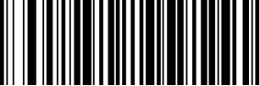

(9140090.)
* UPC-E1 Off
EAN/JAN-13
<Default All EAN/JAN Settings>


(915000.)
Default All EAN/JAN-13 Settings

On/Off

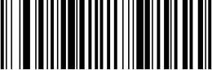

(9150011.)
*On
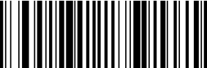

(9150010.)
Off

Note: If you want to convert UPC-A barcodes to EAN-13 format, scan the
UPC-A Off barcode.

Check Digit
This selection allows you to specify whether the check digit should be transmitted at the end of the scanned data or not. Default = On.
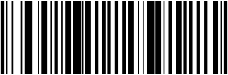

(9150021.)
* On

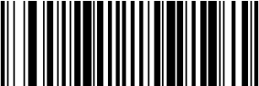

(9150020.)
Off

Addenda
This selection adds 2 or 5 digits to the end of all scanned EAN/JAN-13 data. Default = Off for both 2 Digit and 5 Digit Addenda.
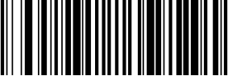

(9150031.)
2 Digit Addenda On
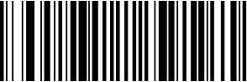

(9150030.)
* 2 Digit Addenda Off


(9150041.)
5 Digit Addenda On
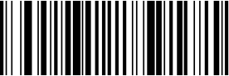

(9150040.)
* 5 Digit Addenda Off

Addenda Required
When Required is scanned, the scanner will only read EAN/JAN-13 barcodes that have addenda. Default = Not Required.


(9150051.)
Required
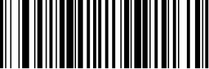

Addenda Separator

(9150050.)
* Not Required

When this feature is On, there is a space between the data from the barcode and the data from the addenda. When turned Off, there is no space. Default
= On.
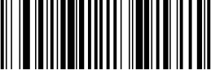

(9150061.)
* On
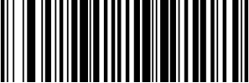

ISBN Translate

(9150060.)
Off

When On is scanned, EAN-13 Bookland symbols are translated into their equivalent ISBN number format. Default = Off.
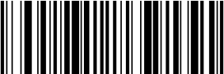

(9150071.)
On

(9150070.)
* Off

EAN/JAN-8

<Default All EAN/JAN-8 Settings>

On/Off

(916000.)

Default All EAN/JAN-8 Settings


(9160011.)
* On

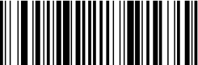

Check Digit

(9160010.)
Off

This selection allows you to specify whether the check digit should be transmitted at the end of the scanned data or not. Default = On.
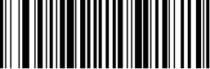

(9160021.)
* On
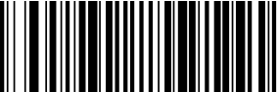

Addenda

(9160020.)
Off

This selection adds 2 or 5 digits to the end of all scanned EAN/JAN-8 data. Default = Off for both 2 Digit and 5 Digit Addenda.

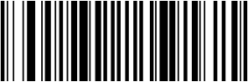
(9160031.)
2 Digit Addenda On

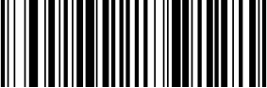

(9160041.)
5 Digit Addenda On



(9160030.)
- 2 Digit Addenda Off

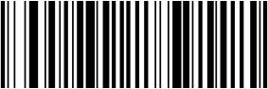

(9160040.)
- 5 Digit Addenda Off

Addenda Required
When Required is scanned, the scanner will only read EAN/JAN-8 barcodes that have addenda. Default = Not Required.
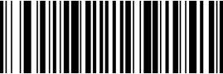

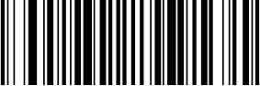
(9160051.)
Required

(9160050.)
* Not Required

Addenda Separator

When this feature is On, there is a space between the data from the barcode and the data from the addenda. When turned Off, there is no space. Default
= On.
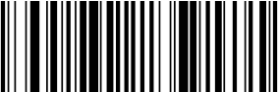

(9160061.)
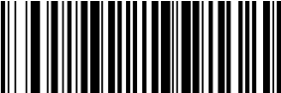
* On

(9160060.)
Off

MSI

On/Off

<Default All MSI Settings>
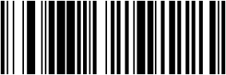

(917000.)
Default All MSI Settings

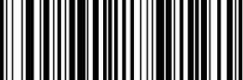
(9170011.)
On

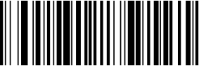

(9170010.)
* Off

Check Characte
MSI barcodes use different types of check characters. You can conﬁgure the barcode scanner to read the MSI barcode using the check character. Default = Validate MOD 10, but Don’t Transmit
When Check Character is set to Validate MOD 10 and Transmit, the scanner will only read MSI barcodes printed with the speciﬁed type check character(s), and will transmit the character(s) at the end of the scanned data.
When Check Character is set to Validate MOD 10, but Don’t Transmit, the unit will only read MSI barcodes printed with the speciﬁed type check character(s), but will not transmit the check character(s) with the scanned data.
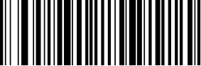

(9170020.)
* Validate MOD 10, but Don’t Transmit
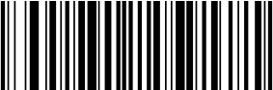

(9170021.)
Validate MOD 10 and Transmit
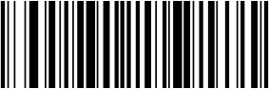

(9170026.)
Disable MSI Check Characters

Message Length
Scan the barcodes below to change the message length. Refer to Message Length Description for additional information. Minimum and Maximum lengths = 4-48. Minimum Default = 4, Maximum Default = 48.
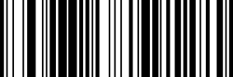

(917004.)
Minimum Message Length
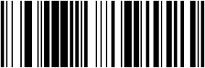

(917003.)
Maximum Message Length

GS1 DataBar Omnidirectional
< Default All GS1 DataBar Omnidirectional Settings >
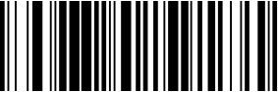

On/Off

(918000.)
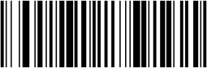
Default All GS1 DataBar Omnidirectional Settings

(9180011.)
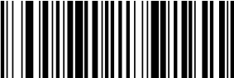
* On

GS1 DataBar Limited

(9180010.)
Off

< Default All GS1 DataBar Limited Settings >
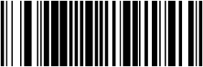

On/Off

(919000.)
Default All GS1 DataBar Limited Settings

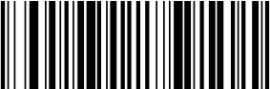
(9190011.)
* On

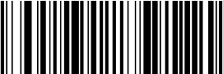

(9190010.)
Off

On/Off

(920000.)

Default All GS1 DataBar Expanded Settings

(9200011.)
* On
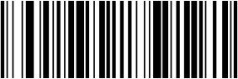

(9200010.)
Off

Message Length
Scan the barcodes below to change the message length. Refer to Message Length Description for additional information. Minimum and Maximum lengths = 4-74. Minimum Default = 4, Maximum Default = 74.
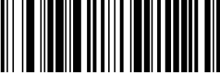

(920003.)
Minimum Message Length
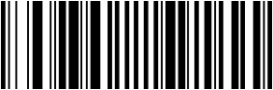

(920002.)
Maximum Message Length

On/Off

(924000.)
Default All PD417 Settings

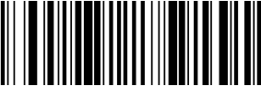

(9240011.)
* On

Message Length

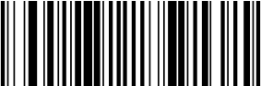

(9240010)
Off

Scan the barcodes below to change the message length. Refer to Message Length Description for additional information. Minimum and Maximum lengths = 1-2750. Minimum Default = 1, Maximum Default = 2750.


(924003.)
Minimum Message Length


(924002.)
Maximum Message Length

On/Off

(928000.)
Default All QR Code Settings

This selection applies to both QR Code and Micro QR Code.


(9280011.)
* On



Message Length

(9280010.)
Off

Scan the barcodes below to change the message length. Refer to Message Length Description for additional information. Minimum and Maximum lengths = 1-7089. Minimum Default = 1, Maximum Default = 7089.


(928003.)
Minimum Message Length


(928002.)
Maximum Message Length

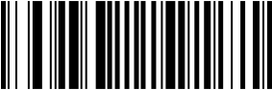

On/Off

(930000.)
Default All Data Matrix Settings


(9300011.)
* On

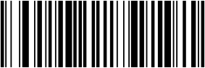

Message Length ^{(9300010.)}
Scan the barcodes below to change the message length. Refer to Message Length Description for additional information. Minimum and Maximum lengths = 1-3116. Minimum Default = 1, Maximum Default = 3116.
Off


(930002.)
Minimum Message Length


(930003.)
Maximum Message Length

On/Off

(931000.)
Default All Aztec Code Settings

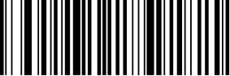

(9310011.)
* On



Message Length

(9310010.)
off

Scan the barcodes below to change the message length. Refer to Message Length Description for additional information. Minimum and Maximum lengths = 1-3832. Minimum Default = 1, Maximum Default = 3832.
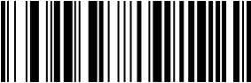

(931003.)
Minimum Message Length

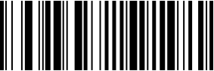

(931002.)
Maximum Message Length

(936000.)
Default All China Post (Hong Kong 2 of 5)Settings

On/Off

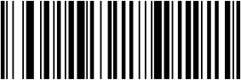
(9360011.)
On

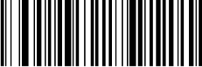

Message Length

(9360010.)
* Off

Scan the barcodes below to change the message length. Refer to Message Length Description for additional information. Minimum and Maximum lengths = 2-80. Minimum Default = 4, Maximum Default = 80.
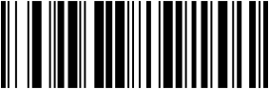

(936003.)
Minimum Message Length


(936002.)
Maximum Message Length

Korea Post

On/Off

<Default All Korea Post Settings>
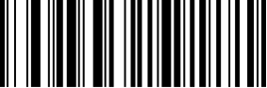

(937000.)
Default All Korea Post Settings

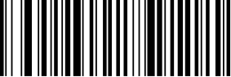

(9370011.)
On



Message Length

(9370010.)
* Off

Scan the barcodes below to change the message length. Refer to Message Length Description for additional information. Minimum and Maximum lengths = 2-80. Minimum Default = 4, Maximum Default = 48.
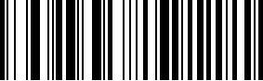

(937003.)
Minimum Message Length


(937002.)
Maximum Message Length

Check Digit
This selection allows you to specify whether the check digit should be transmitted at the end of the scanned data. Default = Don’t Transmit.


(9370041.)
On
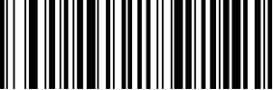

Han Xin Code

On/Off

(9370040.)
* Off

<Default All Han Xin Code Settings>
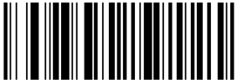

(932000.)
Default All Han Xin Code Settings

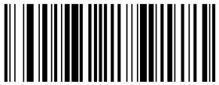

(9320011.)
On

Message Length

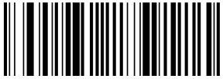

(9320010.)
* Off

Scan the barcodes below to change the message length. Refer to Message Length Description for additional information. Minimum and Maximum lengths = 1-1000. Minimum Default = 1, Maximum Default = 1000.

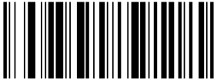

(932003.)
Minimum Message Length

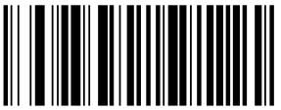

(932002.)
Maximum Message Length

Maxi code

<defalt all maxi code settings>
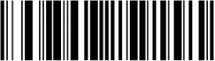

On/Off

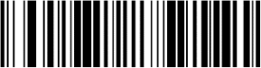

(9290011.)
On
(929000.)

Message Length

(9290010.)
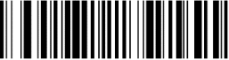
Off

Scan the barcodes below to change the message length. Refer to Message Length Description for additional information. Minimum and Maximum lengths = 1-150. Minimum Default = 1, Maximum Default = 150.
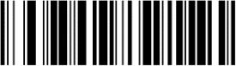

(929003.)
Minimum Message Length
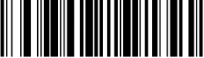

(929002.)
Maximum Message Length

Micropdf

<defalt all micropdf settings>

On/Off

(925000.)

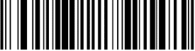
(9250011.)
On

Message Length



(9250010.)
Off

Scan the barcodes below to change the message length. Refer to Message Length Description for additional information. Minimum and Maximum lengths = 1-366. Minimum Default = 1, Maximum Default = 366.
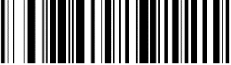

(925003.)
Minimum Message Length
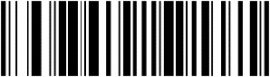

(925002.)
Maximum Message Length

Composites

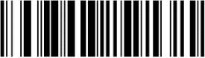
<defalt all composites settings>

On/Off

(926000.)

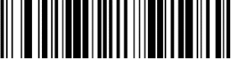
(9260011.)
On

Message Length

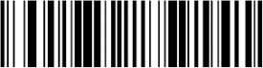

(9260010.)
Off

Scan the barcodes below to change the message length. Refer to Message Length Description for additional information. Minimum and Maximum lengths = 1-2435. Minimum Default = 1, Maximum Default = 2435.
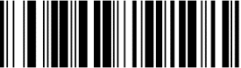

(926004.)
Minimum Message Length
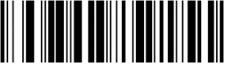

(926003.)
Maximum Message Length

Codablock A

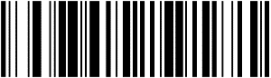
<defalt all composites settings>

On/Off

(922000.)


(9220011.)
On

Message Length



(9220010.)
Off

Scan the barcodes below to change the message length. Refer to Message Length Description for additional information. Minimum and Maximum lengths = 1-600. Minimum Default = 1, Maximum Default = 600.
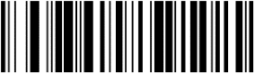

(922003.)
Minimum Message Length
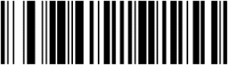

(922002.)
Maximum Message Length

On/Off

(923000.)

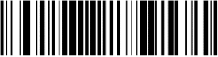
(9230011.)
On

Message Length

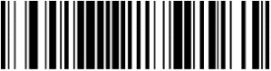

(9230010.)
Off

Scan the barcodes below to change the message length. Refer to Message Length Description for additional information. Minimum and Maximum lengths = 1-2048. Minimum Default = 1, Maximum Default = 2048.
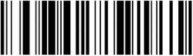

(923003.)
Minimum Message Length
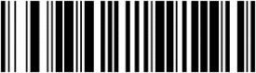

(923002.)
Maximum Message Length

Disable GS1 Data Matrix

Scan the barcode to disable GS1 Data Matrix

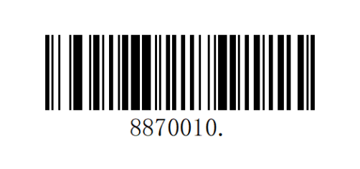
On

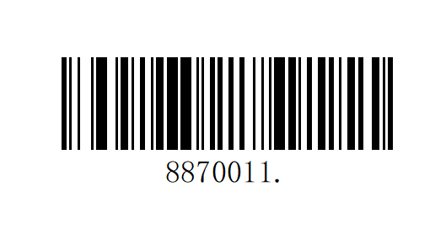
Off

Show Software Revision
Scan the barcode below to output the current software revision, unit serial number, and other product information.
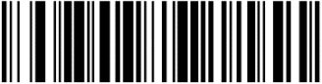

(809004?.)
Show Revision

Problem: The barcode scanner does not work.
possible reason：
- The barcode scanner is not powered, check the power of the equipment.
- If you are using an incorrect cable, use the cable that was originally conﬁgured.
- The cable interface is loose and reconnected.
- Check if the button is normal.
Problem: The barcode scanner scans normally, but the data output is incorrect. possible reason：
- The cable interface is loose and reconnected.
- Barcode scanner may not be conﬁgured to display the correct terminal.
- If you are using a USB to RS232 cable, if the data output is garbled, it may be that the data reception speed of the device does not match the output speed of the barcode scanner.

Problem: Barcode scanner does not decode some barcodes. possible reason：
- The barcode is defective. Try to scan the same type of test barcode to see if it can be interpreted.
- The distance between the barcode scanner and the barcode is not suitable. Please move closer or move away the barcode.
- For barcodes with poor print quality, the preferred reading distance is 5-10 cm.
- Conﬁrm that your device is enabled for this barcode type.
Problem: Other conditions cannot be decoded. possible reason：
- Turn off the device power; properly connect the device to the barcode scanner; turn on the device and test it.
- If the problem still cannot be solved, please contact the dealer or the manufacturer.

M aintenance
- Stains and dust on the scanning window can sometimes affect the normal operation of the barcode scanner. When cleaning, use a good quality tissue to wipe gently, or use a soft cloth to clean.
If you use a paper with poor paper quality for a long time, it will damage the surface ﬁnish of the window and affect the reading effect of the barcode scanner.
- The outer shell of the barcode scanner can be wiped with a soft, clean cloth. If necessary, add a small amount of detergent to the water, wipe it with a soft cloth and rub it.
- Do not spray any liquid on the window.
- The scanning window must be kept clean and the supplier is not liable for damage caused by improper maintenance.

Customer Service
If you need help installing or troubleshooting a device, please contact us

Reference Charts Symbology Charts Linear Symbologies
Symbology | AIM
Symbology | ID | Possible Modiﬁers  （m） | ID | Hex
All Symbologies |  |  |  | 99
Codabar | ]Fm | 0-1 | a | 61
Code 11 | ]H3 |  | h | 68
Code 128 | ]Cm | 0, 1, 2, 4 | j | 6A
Code 32 Pharmaceutical (PARAF) | ]X0 |  | < | 3C
Code 39 (supports Full ASCII mode) | ]Am | 0, 1, 3, 4,  5,7 | b | 62
TCIF Linked Code 39 (TLC39) | ]L2 |  | T | 54
Code 93 and 93i | ]Gm | 0-9, A-Z, a-m | i | 69
EAN | ]Em | 0, 1, 3, 4 | d | 64
EAN-13 (including Bookland EAN) | ]E0 |  | d | 64
EAN-13 with Add-On | ]E3 |  | d | 64
EAN-13 with Extended Coupon | ]E3 |  | d | 64
EAN-8 | ]E4 |  | D | 44
EAN-8 with Add-On | ]E3 |  | D | 44

Symbology | AIM
Symbology | ID | Possible  Modiﬁers  （m） | ID | Hex
GS1
GS1 DataBar | ]em | 0 | y | 79
GS1 DataBar Limited | ]em |  | { | 7B
GS1 DataBar Expanded | ]em |  | } | 7D
GS1-128 | ]C1 |  | I | 49
2 of 5
China Post (Hong Kong 2 of | ]X0 |  | Q | 51
Interleaved 2 of 5 | ]Im | 0, 1, 3 | e | 65
Matrix 2 of 5 | ]X0 |  | m | 6D
NEC 2 of 5 | ]X0 |  | Y | 59
Straight 2 of 5 IATA | ]Rm | 0, 1, 3 | f | 66
Straight 2 of 5 Industrial | ]S0 |  | f | 66
MSI | ]Mm | 0, 1 | g | 67
Telepen | ]Bm |  | t | 74
UPC |  | 0, 1, 2, 3,  8,
UPC-A | ]E0 |  | c | 63
UPC-A with Add-On | ]E3 |  | c | 63
UPC-A with Extended Coupon | ]E3 |  | c | 63
UPC-E | ]E0 |  | E | 45
UPC-E with Add-On | ]E3 |  | E | 45
UPC-E1 | ]X0 |  | E | 45
Add Code ID |  |  |  | 5C  80
Add AIM Code ID |  |  |  | 5C  81
Add Backslash |  |  |  | 5C  5C
Batch Mode Quantilty |  |  | 5 | 35
5)
9, A, B, C

2D Symbologies
6
Symbology | AIM
Symbology | ID | Possible Modiﬁers  （m） | ID | Hex
All Symbologies |  |  |  | 99
Aztec Code | ]zm | 0-9, A-C | z | 7A
Chinese Sensible Code (Han Xin Code) | ]X0 |  | H | 48
Codablock A | ]O6 | 0, 1, 4, 5, | V | 56
Codablock F | ]Om | 0, 1,64, 5, | q | 71
Code 49 | ]Tm | 0, 1, 2, 4 | l | 6C
Data Matrix | ]dm | 0-6 | w | 77
GS1 | ]em | 0-3 | y | 79
GS1 Composite | ]em | 0-3 | y | 79
GS1  DataBar Omnidirecti | ]em | 0-3 | y | 79
MaxiCode | ]Um | 0-3 | x | 78
PDF417 | ]Lm | 0-2 | r | 72
MicroPDF417 | ]Lm | 0-5 | R | 52
QR Code | ]Qm | 0-6 | s | 73
Micro QR Code | ]Qm |  | s | 73

Postal Symbologies
Post
Symbology | AIM
Symbology | ID | Possible Modiﬁers  （m） | ID | Hex
All Symbologies |  |  |  | 99
Australian Post | ]X0 |  | A | 41
British Post | ]X0 |  | B | 42
Canadian Post | ]X0 |  | C | 43

Symbology | AIM
Symbology | ID | Possible Modiﬁer s | ID | Hex
China Post | ]X0 | （m） | Q | 51
InfoMail | ]X0 |  | , | 2c
Intelligent Mail Bar  Code | ]X0 |  | M | 4D
Japanese Post | ]X0 |  | J | 4A
KIX (Netherlands) | ]X0 |  | K | 4B
Korea Post | ]X0 |  | ? | 3F
Planet Code | ]X0 |  | L | 4C
Postal-4i | ]X0 |  | N | 4E
Postnet | ]X0 |  | P | 50

ASCII Conversion Chart
Hex | Dec | Char
00 | 0 | NUL （Null char.）
01 | 1 | SOH （Start of Header）
02 | 2 | STX （Start of Text）
03 | 3 | ETX （End of Text）
04 | 4 | EOT （End of Transmission)
05 | 5 | ENQ （Enquiry）
06 | 6 | ACK （Acknowledgment）
07 | 7 | BEL （Bell）
08 | 8 | BS （Backspace）
09 | 9 | HT （Horizontal Tab）
0a | 10 | LF （Line Feed）
0b | 11 | VT （Vertical Tab）
0c | 12 | FF （Form Feed）
0d | 13 | CR （Carriage Return）
0e | 14 | SO （Shift Out）
0f | 15 | SI （Shift In）
10 | 16 | DLE （Data Link Escape）
11 | 17 | DC1 （XON）（Device Control 1）
12 | 18 | DC2 （Device Control 2）
13 | 19 | DC3（XOFF）（Device Control 3）
14 | 20 | DC4 （Device Control 4）
15 | 21 | NAK （Negative Acknowledgment）
16 | 22 | SYN （Synchronous Idle）
17 | 23 | ETB （End of Trans. Block）
18 | 24 | CAN （Cancel）
19 | 25 | EM （End of Medium）
1a | 26 | SUB （Substitute）
1b | 27 | ESC （Escape）
1c | 28 | FS （File Separator）
1d | 29 | GS （Group Separator）
1e | 30 | RS （Request to Send）
1f | 31 | US （Unit Separator）
20 | 32 | SP （Space）
21 | 33 | ! （Exclamation Mark）
22 | 34 | " （Double Quote）
23 | 35 | # （Number Sign）
24 | 36 | $ （Dollar Sign）

 | 25 | 37 | % （Percent）
 | 26 | 38 | & （Ampersand）
 | 27 | 39 | ` （Single Quote）
 | 28 | 40 | (（Right / Closing Parenthesis）
 | 29 | 41 | )（Right / Closing Parenthesis）
 | 2a | 42 | * （Asterisk）
 | 2b | 43 | + （Plus）
 | 2c | 44 | ,（Comma）
 | 2d | 45 | -（Minus / Dash）
 | 2e | 46 | . （Dot）
 | 2f | 47 | / （Forward Slash）
 | 30 | 48 | 0
 | 31 | 49 | 1
 | 32 | 50 | 2
 | 33 | 51 | 3
 | 34 | 52 | 4
 | 35 | 53 | 5
 | 36 | 54 | 6
 | 37 | 55 | 7
 | 38 | 56 | 8
 | 39 | 57 | 9
 | 3a | 58 | ：（Colon）
 | 3b | 59 | ；（Semi-colon）
 | 3c | 60 | < （Less Than）
 | 3d | 61 | = （Equal Sign）
 | 3e | 62 | > （Greater Than）
 | 3f | 63 | ? （Question Mark）
 | 40 | 64 | @ （AT Symbol）
 | 41 | 65 | A
 | 42 | 66 | B
 | 43 | 67 | C
 | 44 | 68 | D
 | 45 | 69 | E
 | 46 | 70 | F
 | 47 | 71 | G
 | 48 | 72 | H
 | 49 | 73 | I
 | 4a | 74 | J
 | 4b | 75 | K
 | 4c | 76 | L
 | 4d | 77 | M
 | 4e | 78 | N
 | 4f | 79 | O

 | 50 | 80 | P
 | 51 | 81 | Q
 | 52 | 82 | R
 | 53 | 83 | S
 | 54 | 84 | T
 | 55 | 85 | U
 | 56 | 86 | V
 | 57 | 87 | W
 | 58 | 88 | X
 | 59 | 89 | Y
 | 5a | 90 | Z
 | 5b | 91 | [ （Left / Opening Bracket）
 | 5c | 92 | \（Back Slash）
 | 5d | 93 | ] （Right / Closing Bracket）
 | 5e | 94 | ^ （Caret / Circumﬂex）
 | 5f | 95 | _ （Underscore）
 | 60 | 96 | ' （Grave Accent）
 | 61 | 97 | a
 | 62 | 98 | b
 | 63 | 99 | c
 | 64 | 100 | d
 | 65 | 101 | e
 | 66 | 102 | f
 | 67 | 103 | g
 | 68 | 104 | h
 | 69 | 105 | i
 | 6a | 106 | j
 | 6b | 107 | k
 | 6c | 108 | l
 | 6d | 109 | m
 | 6e | 110 | n
 | 6f | 111 | o
 | 70 | 112 | p
 | 71 | 113 | q
 | 72 | 114 | r
 | 73 | 115 | s
 | 74 | 116 | t
 | 75 | 117 | u
 | 76 | 118 | v
 | 77 | 119 | w
 | 78 | 120 | x
 | 79 | 121 | y
 | 7a | 122 | z
 | 7b | 123 | { （Left/ Opening Brace）

 | 7c | 124 | | （Vertical Bar）
 | 7d | 125 | } （Right/Closing Brace）
 | 7e | 126 | ~ （Tilde）
 | 7f | 127 | DEL （Delete）

Sample Symbols

UPC-A

01234567890 Interleaved 2 of 5
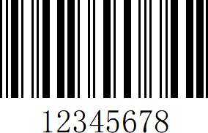
Code 128
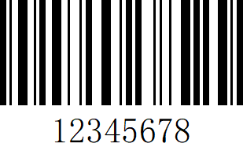

Straight 2 of 5Industrial

123456

Matrix 2 of 5
6543210

Code 93

123456-9$ Straight 2 of 5Industrial

Matrix 2 of 5
123456

6543210 GS1DataBar
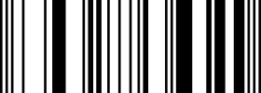

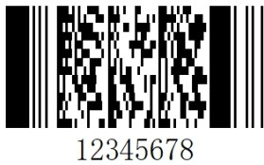
PDF417

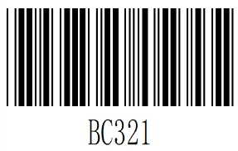
Codabar

Data Matrix

QRCode


Numbers
TestSymbol

Aztec
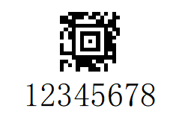

MaxiCode

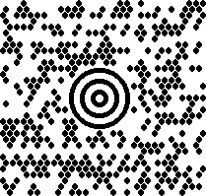
Test Message

Micro PDF417

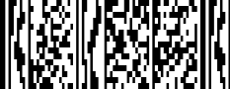
Test Message

Programming Charts

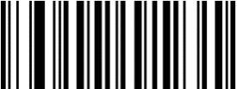

(K0K.)
0

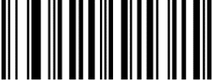

(K2K.)
2

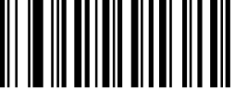

(K4K.)
4

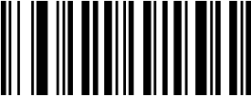

(K6K.)
6

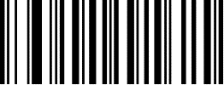

(K1K.)
1



(K3K.)
3

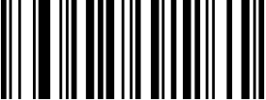

(K5K.)
5

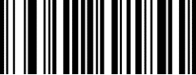

(K7K.)
7

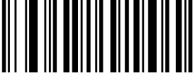(K8K.)
8

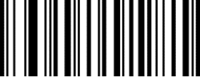

(KAK.)
A

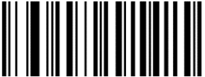

(KCK.)
C

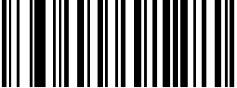

(KEK.)
E

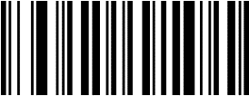

(K9K.)

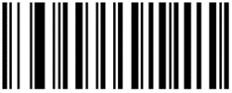
(KBK.)
B

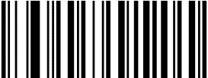

(KDK.)
D

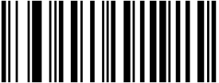

(KFK.)
F



(800002.)
Save

(800000.)
Discard

Note: If an error occurs while scanning a letter or number (before scanning the "Save" barcode), scan the "Discard" barcode, rescan the correct letter or number, and then scan the "Save" barcode.

